**Name**

**Advanced Programming in Java**

**Lab Exercise 12/13/2021**

Your task today is to create a bowling simulator that will score 4 players. The player’s scores will be stored in disk files named “one.txt”, “two.txt”, “three.txt”, “four.txt”.

Use the following score sheet to aid you in building your text files.

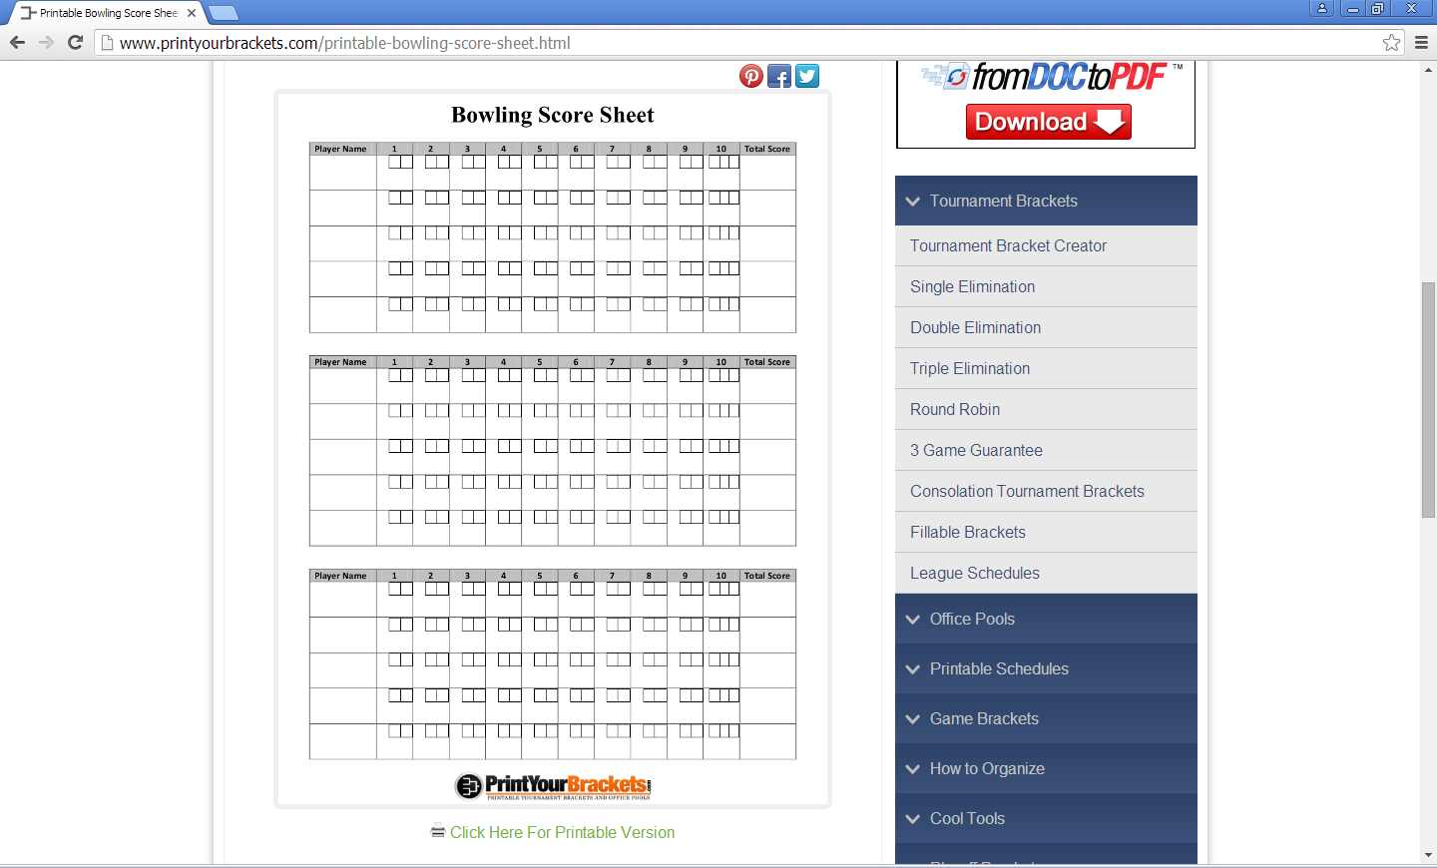

Your output should resemble this:

Player 1 score

Frame

1 2 3 4 5 6 7 8 9 10

9 12 19 25 30 39 53 59 67 76

Player 2 score

Frame

1 2 3 4 5 6 7 8 9 10

8 14 21 30 39 48 62 67 87 104

Player 3 score

Frame

1 2 3 4 5 6 7 8 9 10

7 24 33 40 58 66 81 101 120 129

Player 4 score

Frame

1 2 3 4 5 6 7 8 9 10

20 46 65 74 92 101 129 149 167 186

**Color Mapping**

## Problem

A color reduction is a mapping from a set of discrete colors to a smaller one. The solution to this problem requires that you perform just such a mapping in a standard twenty-four bit RGB color space. The input consists of a target set of sixteen RGB color values, and a collection of arbitrary RGB colors to be mapped to their closest color in the target set. For our purposes, an RGB color is defined as an ordered triple (*R*,*G*,*B*) where each value of the triple is an integer from 0 to 255. The distance between two colors is defined as the Euclidean distance between two three-dimensional points. That is, given two colors (*R*1,*G*1,*B*1) and (*R*2,*G*2,*B*2), their distance *D* is given by the equation

.

The input file is a list of RGB colors, one color per line, specified as three integers from 0 to 255 delimited by a single space. The first sixteen colors form the target set of colors to which the remaining colors will be mapped.

## Output

For each color to be mapped, output the color and its nearest color from the target set.

## Example

|  |  |
| --- | --- |
| Input  0 0 0  255 255 255  0 0 1  1 1 1  128 0 0  0 128 0  128 128 0  0 0 128  126 168 9  35 86 34  133 41 193  128 0 128  0 128 128  128 128 128  255 0 0  0 1 0  0 0 0  255 255 255  253 254 255  77 79 134  81 218 0 | Output  (0,0,0) maps to (0,0,0)  (255,255,255) maps to (255,255,255)  (253,254,255) maps to (255,255,255)  (77,79,134) maps to (128,128,128)  (81,218,0) maps to (126,168,9) |

When you have completed the project, submit your source code.